**Advanced What-If analysis**

**Create the following parameters**

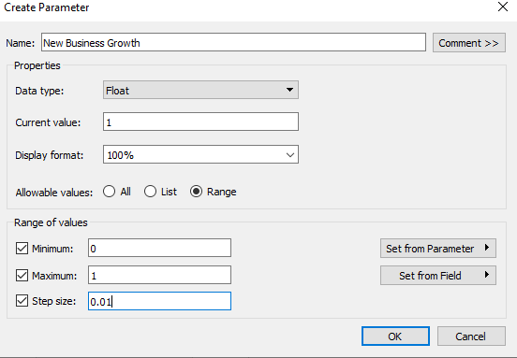

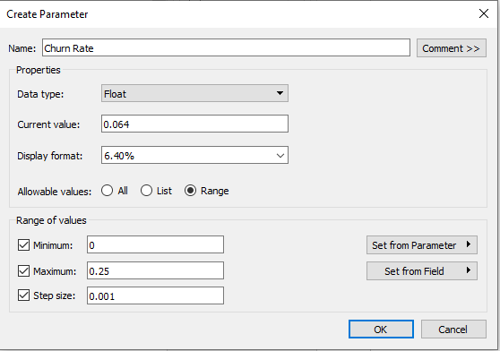

Create the following Calculated fields.

**Sales Forecast**

**[Sales]*(1-[Churn Rate])*(1+[New Business Growth])**

**Difference**

**SUM([Sales])-SUM([Sales Forecast])**

**Create a Workbook based on the attachment below.**

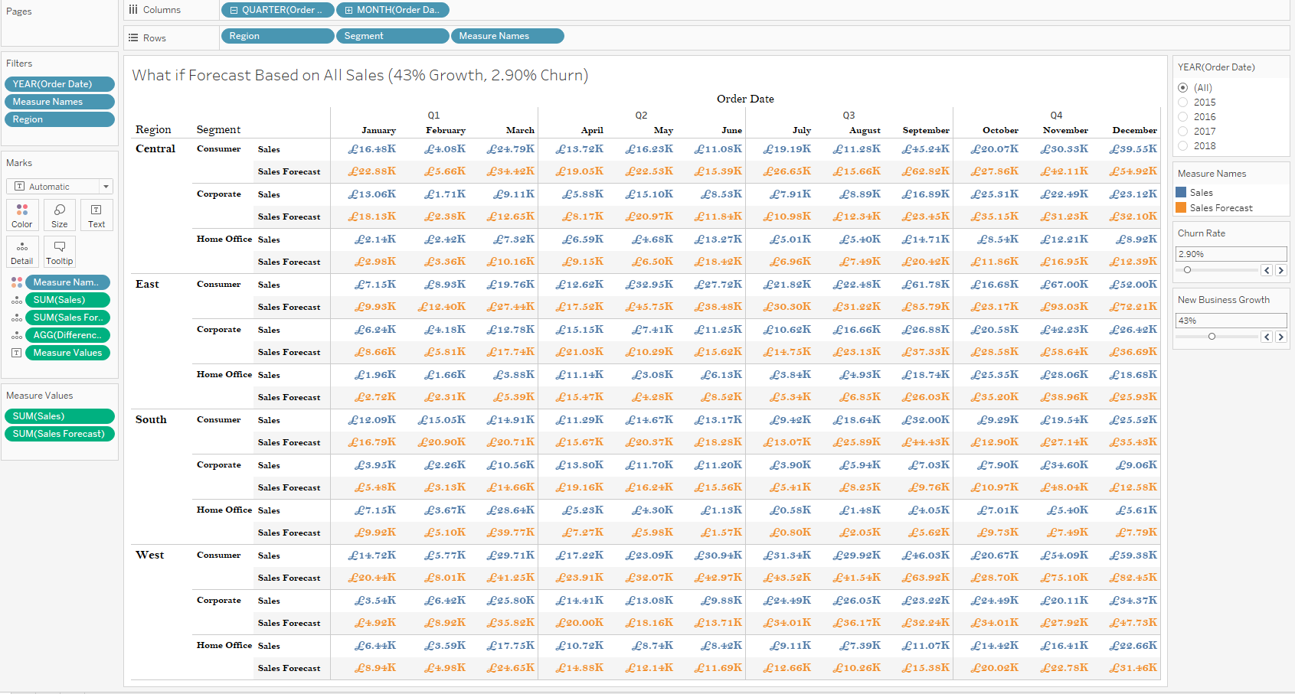

**Go To Analysis on the Top and Show Totals Based On the requirement.**

